**Bountiful Foods Site Plan**

|  |  |
| --- | --- |
| **Site Purpose** | * Enable customers to conveniently browse and order a wide variety of fresh, organic, and locally grown foods from Bountiful Foods, including fruits, produce, fruit drinks, and fruit bags. This purpose focuses on providing a user-friendly platform for customers to place orders online. * Provide information about the physical storefront in Carlsbad, California, including location, operating hours, and any special offers or events. This purpose aims to attract local customers who prefer to visit the store in person. * Educate visitors about the benefits of healthy eating and organic produce, emphasizing Bountiful Foods' commitment to providing fresh and organic food options. This purpose focuses on creating awareness and attracting customers who prioritize their health and well-being. |
| **Target Audience** | * Health-conscious individuals living in or visiting the coastal areas of Los Angeles to San Diego, who prioritize fresh, organic, and locally grown foods and value convenience in their food purchasing and consumption habits. |
| **Personas** | **Olivia Martinez**  Female, 35 years old   * Lives in Carlsbad, California * Embraces an organic lifestyle and values sustainable farming practices * Prefers to support local businesses and knows the importance of buying fresh produce directly from farmers * Enjoys trying new fruit drinks and snacks   Goals:   * Seeks a reliable source of organic and locally grown foods * Values the convenience of online ordering and occasional visits to the physical store * Actively seeks information about the nutritional benefits of different fruits and produce * Regularly follows Bountiful Foods on social media for updates and promotions |
|  | **Ethan Hansel**  Male, 28 years old   * Lives in Los Angeles but travels frequently to San Diego for business * Prioritizes healthy eating and seeks organic food options * Prefers to order food online or from food trucks for convenience * Values sustainable and eco-friendly practices   Goals:   * Looks for website that provides information about Bountiful Food’s food truck schedule and location in the coastal area * Seeks to explore and try different organic fruit drinks and snacks while on the go * Appreciates a user-friendly online ordering system with easy delivery options |
|  | **Tina Herald**  Female, 45 years old   * Visiting the coastal areas as a tourist from another state * Seeks healthy and fresh food options while on vacation * Prefers to explore local farmers` markets and stores to experience the local food culture * Interested in learning about the nutritional benefits of different fruits and produce   Goals:   * Looks for a website that provides information about Bountiful Foods` physical storefront location in Carlsbad * Wants to plan a visit to the store during her stay to purchase fresh organic produce and fruit bags * Seeks recommendations for nearby restaurants and eateries that prioritize healthy and organic ingredients. |
| **Typography** | Playfair Display & Lato |

|  |  |  |  |
| --- | --- | --- | --- |
| Element | Font Family | Font Size | Sample |
| Site Header | Fairplay Display | 40px | Sample |
| Primary Navigation | Lato | 30px | Sample |
| Footer Navigation | Lato | 20px | Sample |
| Heading 1 (h1) | Fairplay Display | 30px | Sample |
| Heading 2 (h2) | Fairplay Display | 25px | Sample |
| Heading 3 (h3) | Fairplay Display | 20px | Sample |
| Paragraphs | Lato | 16px | Sample |

Site Map

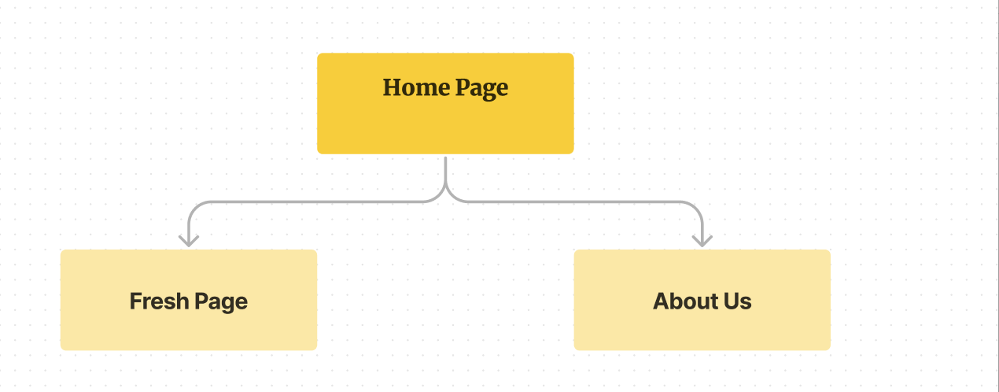

Color Scheme



Small View

Wireframe

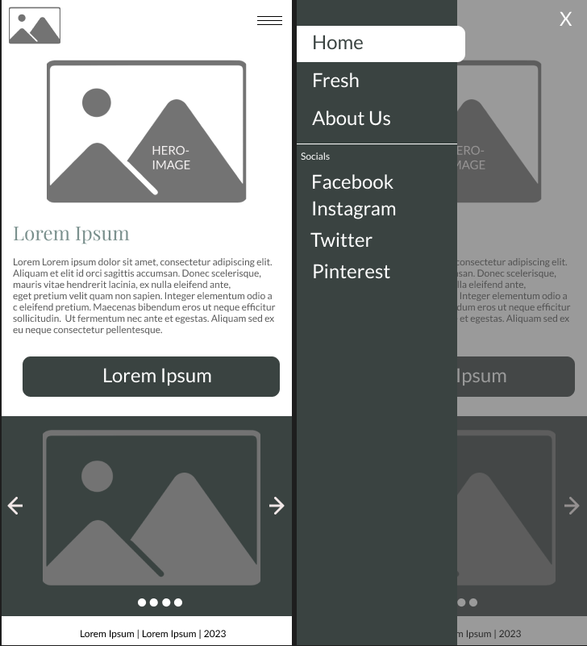

Medium View

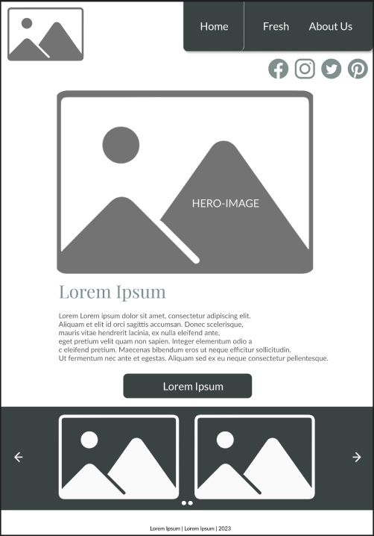

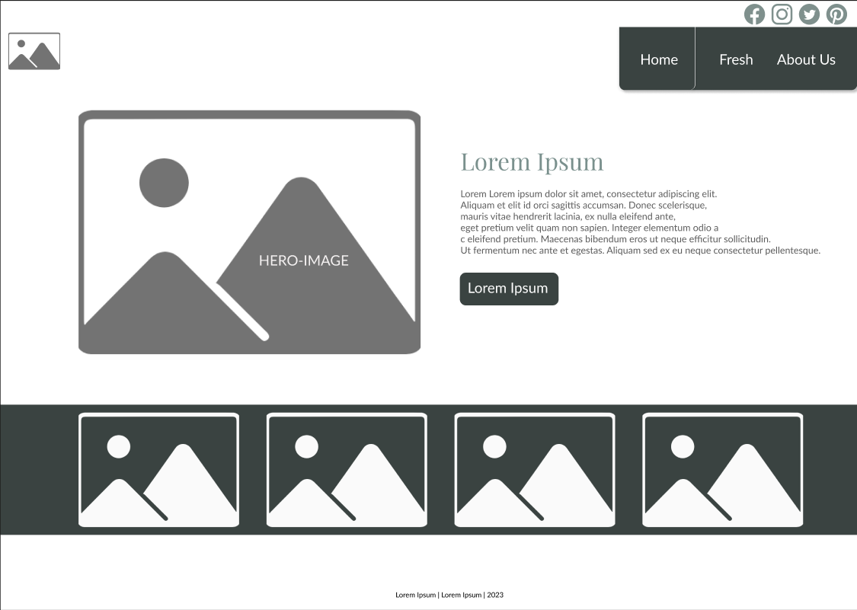

Large View